West Chinnock Community Playground
Tennis Court

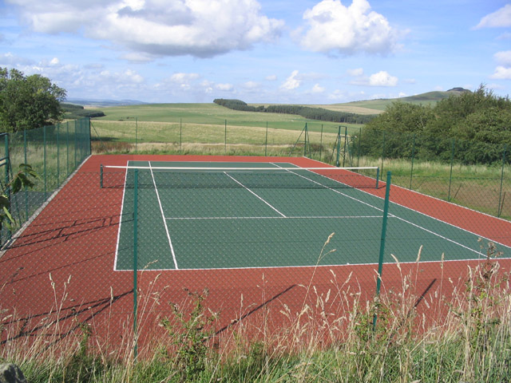
Well, it looks very similar to ours!

Did you know that you can rent the Tennis court from just £2 for a very relaxed 1.5-hour session?
Alternatively, you could take out an annual pass, where you are given a key to the tennis court, for one year, to use as and when you want for just for £30.
So, if you like to keep fit, or start afresh in the spring, contact Tom Jones on 881526, Neil Cochran on 881585 or Bill Mannering on 881414 for the use of the court or annual pass.
The court can also be hired for other activities such as children’s parties or 5-a-side football.

